Make sure you are connected to the UC_CDW database. Open a query which you created in Brio while connected to Sybase IQ.
Select the Table Catalog, right-click, and select “Full Names”. This will show you the fully qualified table names. In this example, “PERSONNEL” is the schema for the tables displayed.
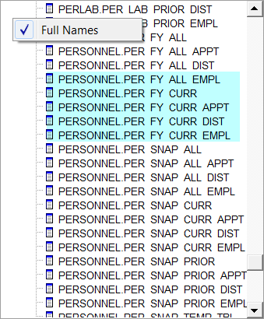
Select the Table in your Query section, right-click and select Properties.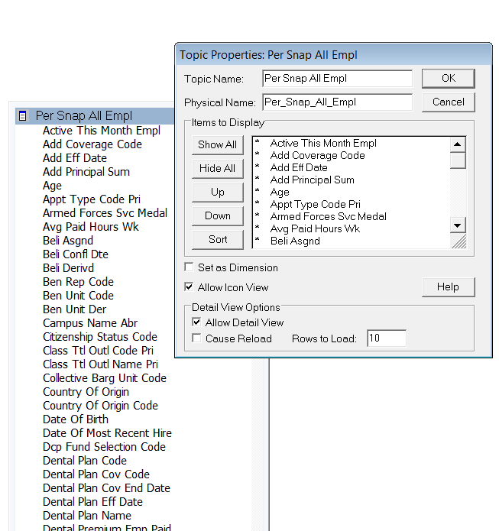

If the Physical Name does not contain the table name (Per_Snap_All_Empl in this example) prefixed with the schema name (“PERSONNEL” in this example), add the schema name. Note that the schema name does not have to be all upper case as displayed in the “Full names”.
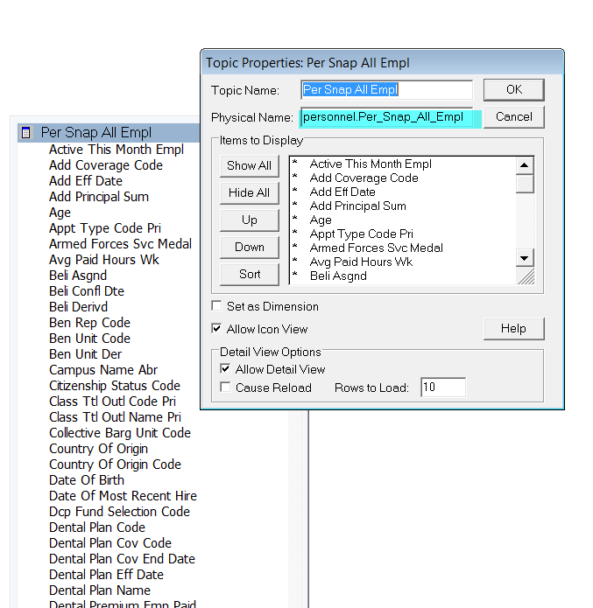
Run the query to make sure it connects to the DB2 database. You might want to add a record limit in Query Options.
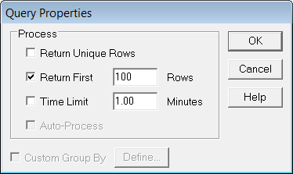
If the query runs as expected, save the query.

